**Phase 7: Integration & External Access**

**➣Named Credentials**

**•** Used to securely store the connection to IoT platforms that provide bin fill-level data.

**•** Example:Create a Named Credential for <https://iot.greencity.com/api.>

**•** Benefit: Simplifies authentication for REST callouts.

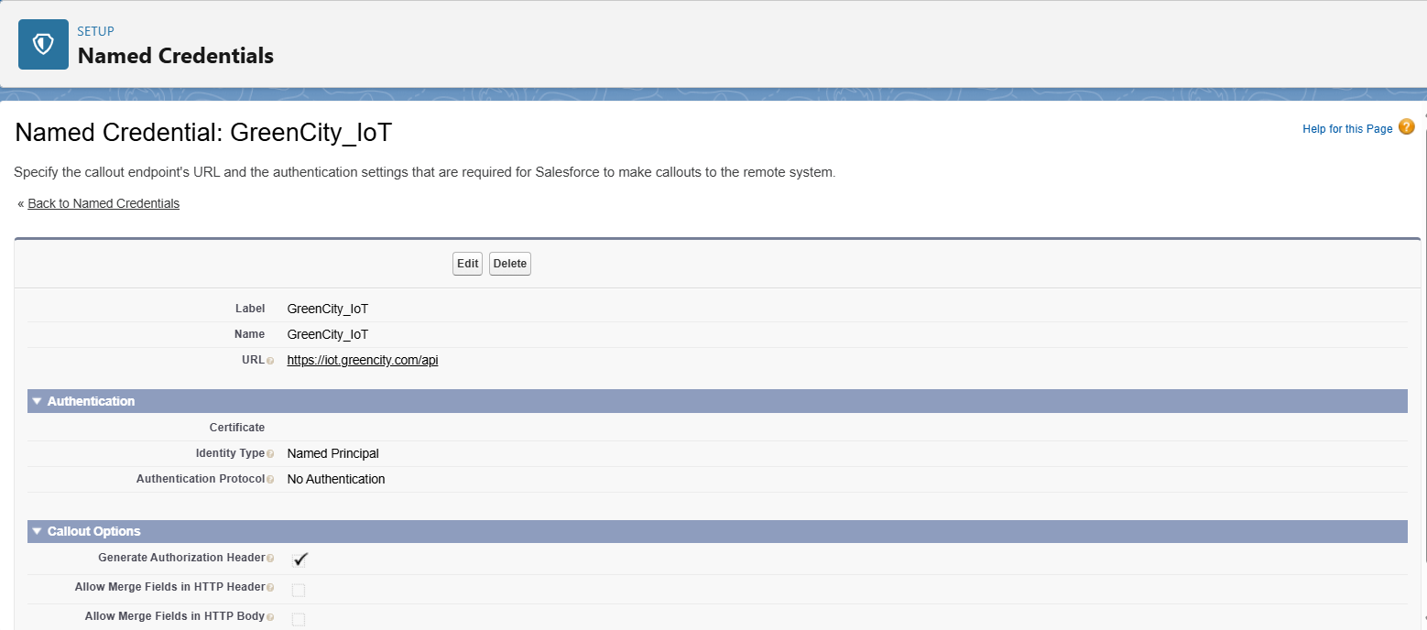

**➣Web Services (REST) + Callouts**

**•** REST Callouts were used to pull IoT sensor readings into Salesforce.

**•** Example: A scheduled Apex class makes a callout → fetches bin status → updates Waste_Bin_c.Fill_Level_c.

**•** Remote Site Settings are configured to allow these API calls.

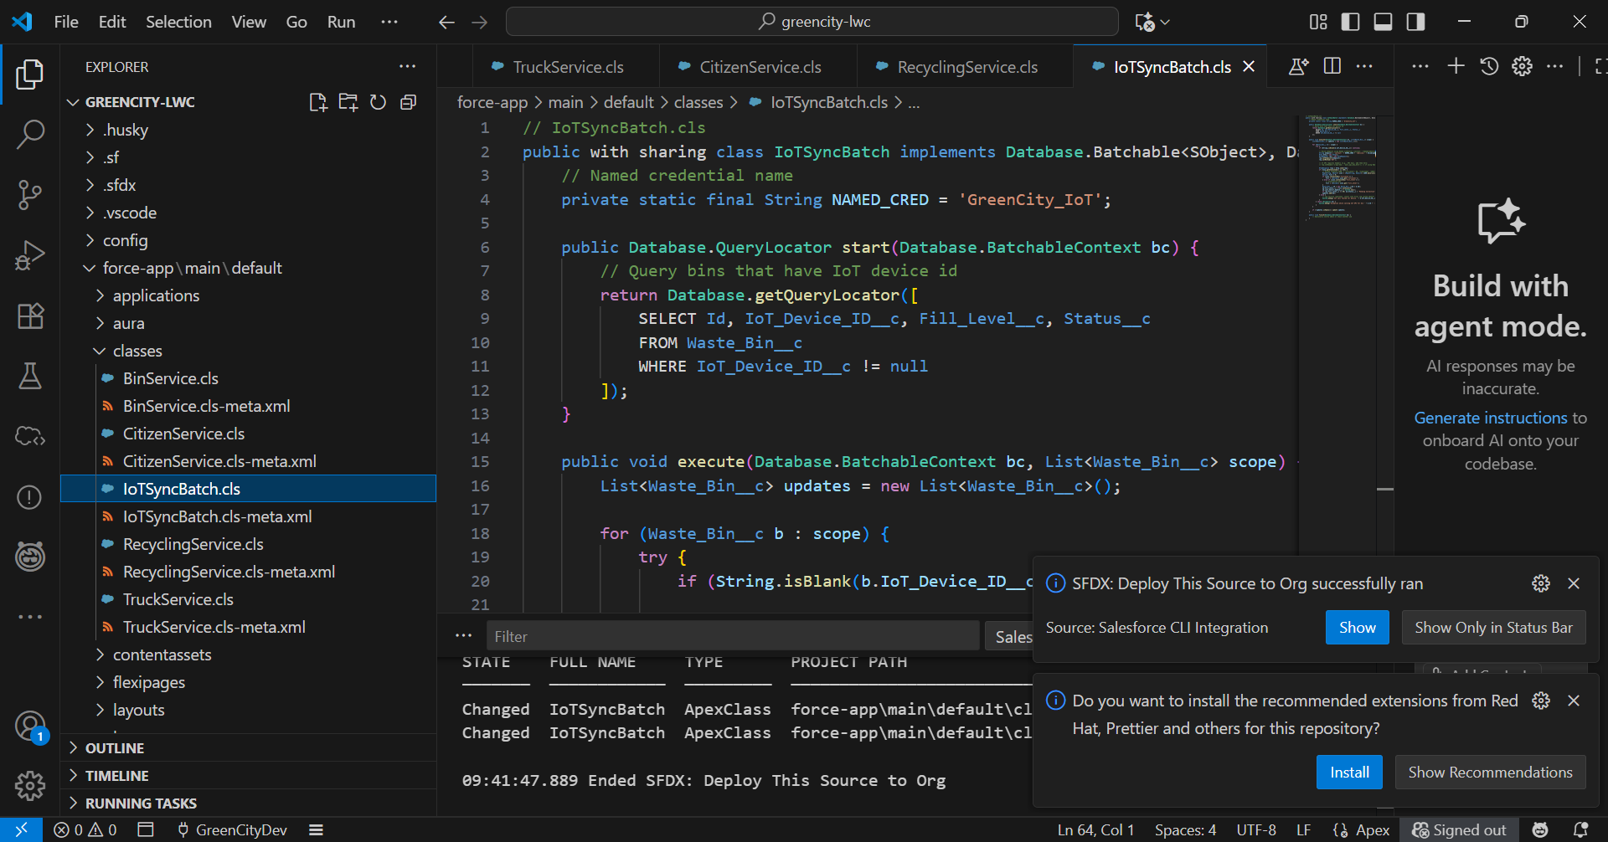

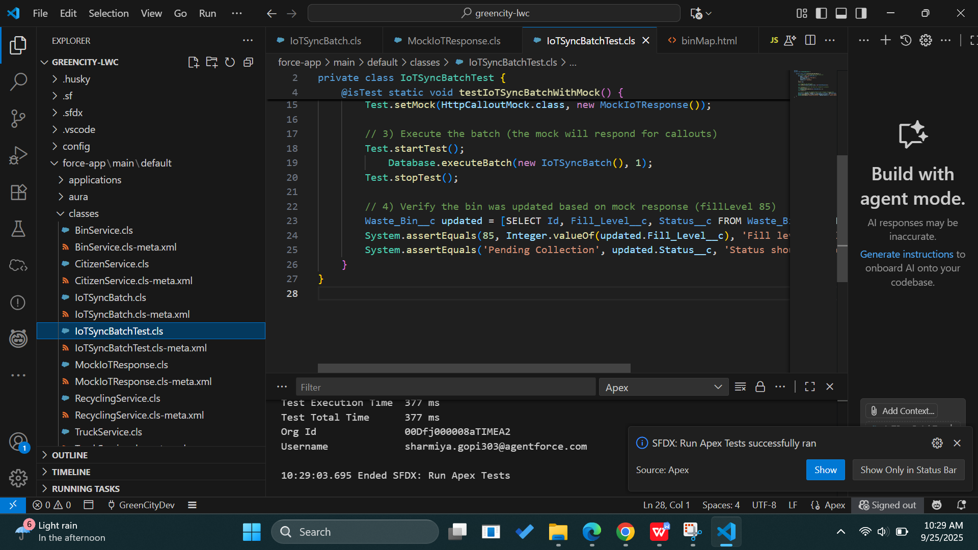

**➣Platform Events**

**•** Used for real-time notifications inside Salesforce.

**•** Example: When a Pickup Request is created, a Platform Event notifies the supervisor’s dashboard instantly.

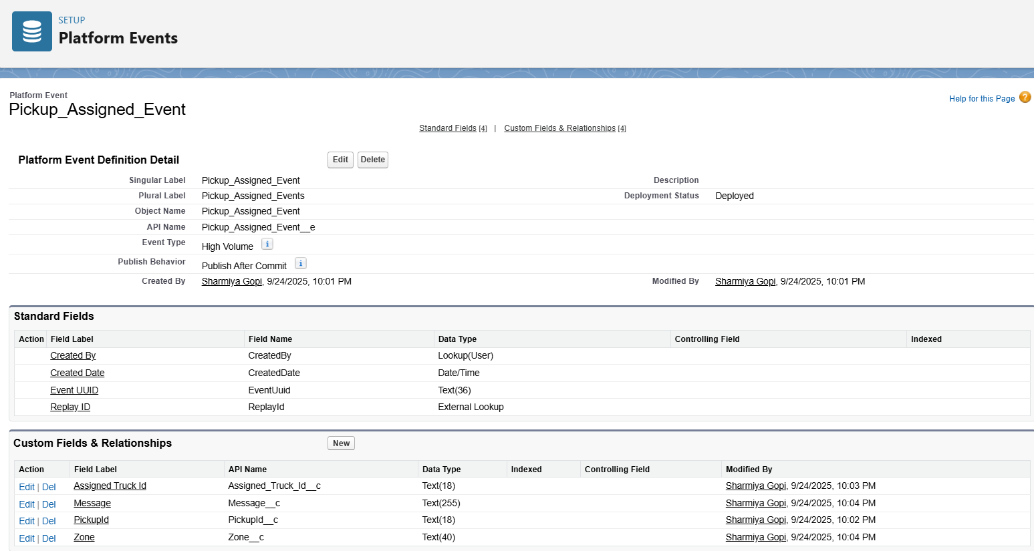

**➣API Limits**

**•** Monitored to ensure IoT integrations do not exceed Salesforce daily API usage.

**•** Important since IoT sensors can send frequent updates.

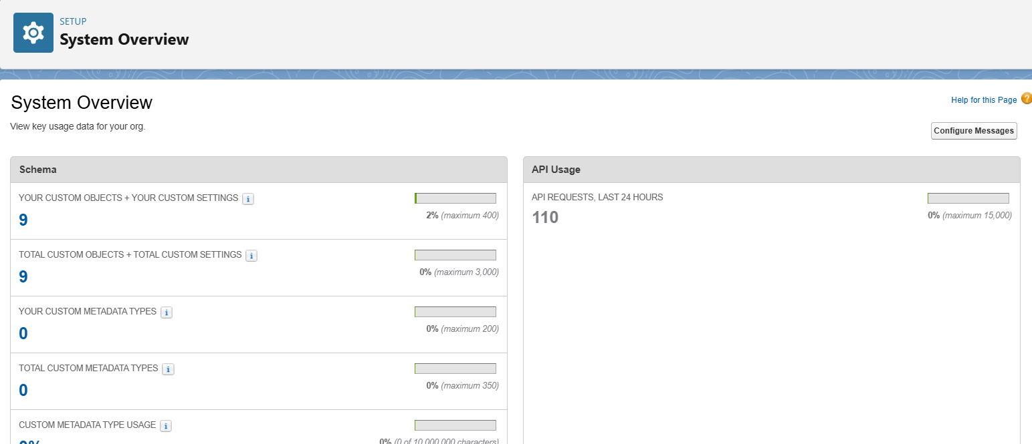

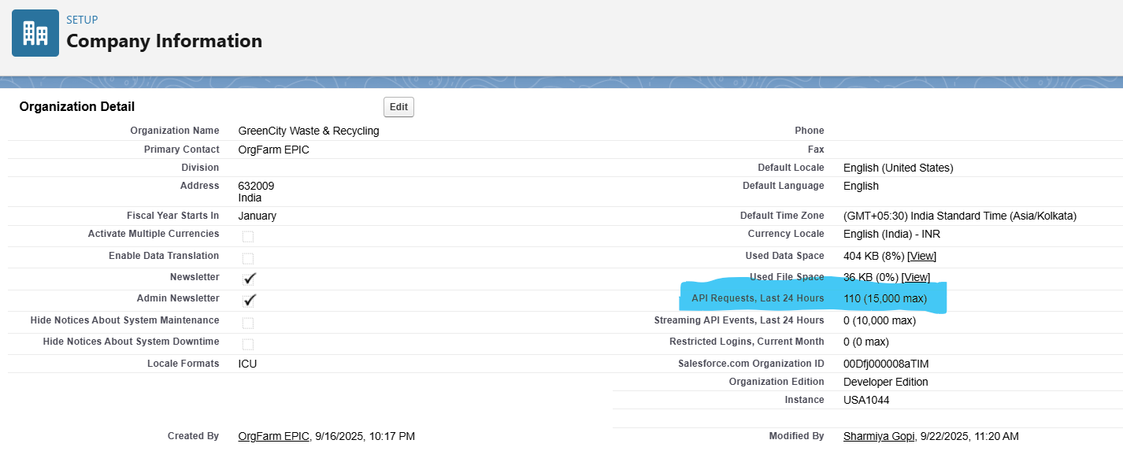

**Phase 8: Data Management & Deployment**

**➣Data Import Wizard**

**•** Used initially to bulk-upload Waste Bins, Trucks, and Citizen records.

**•** Simple UI, good for non-technical admins.

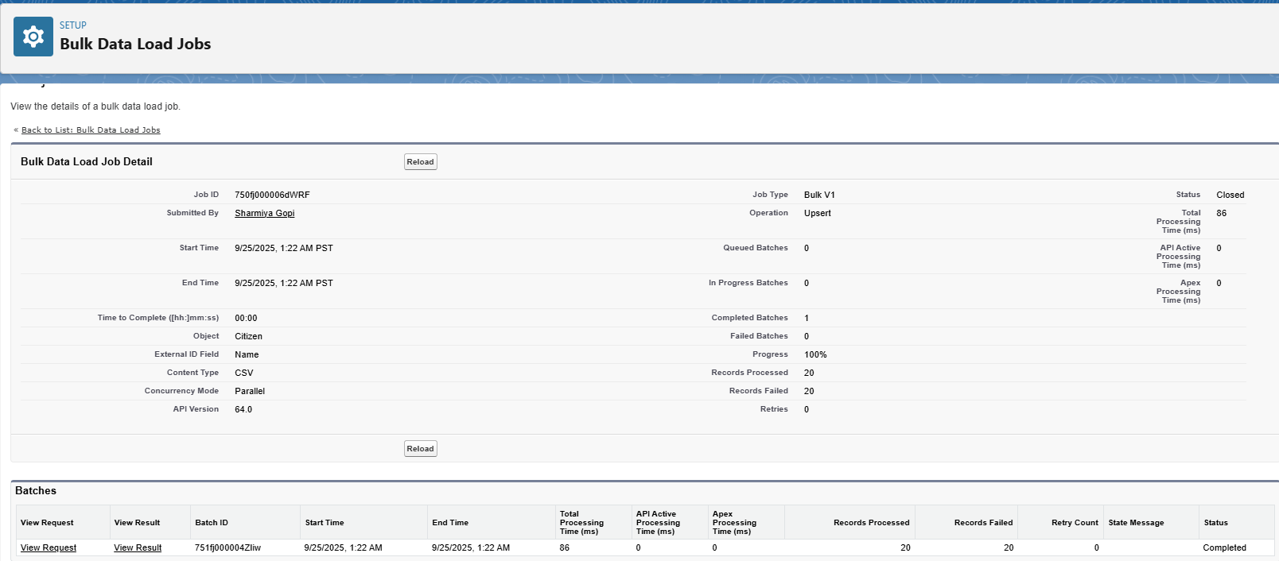

**➣Data Loader**

**•** Used for larger imports/updates (e.g., adding 1000+ recycling records from legacy system).

**•** Supports CSV files with insert, update, upsert, delete.

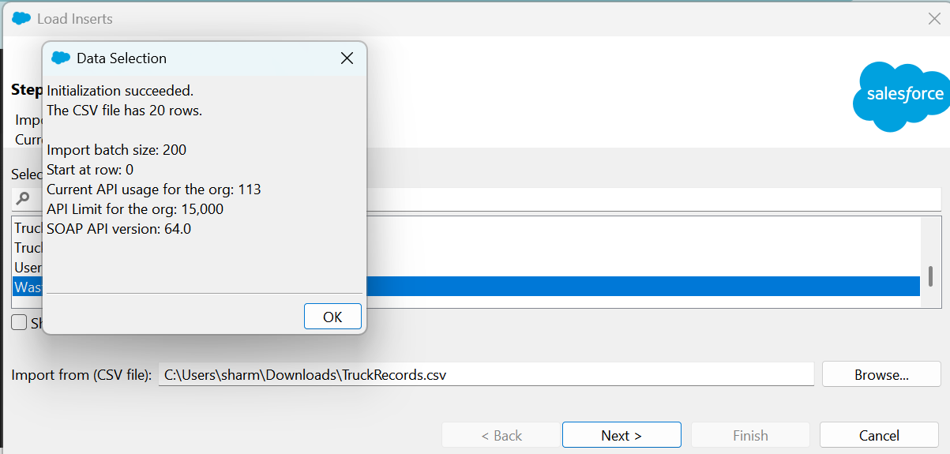

**➣Duplicate Rules**

**•** Prevent duplicate Pickup Requests for the same bin.

**•** Example: If a bin already has a “Pending Collection” request, block a new one.

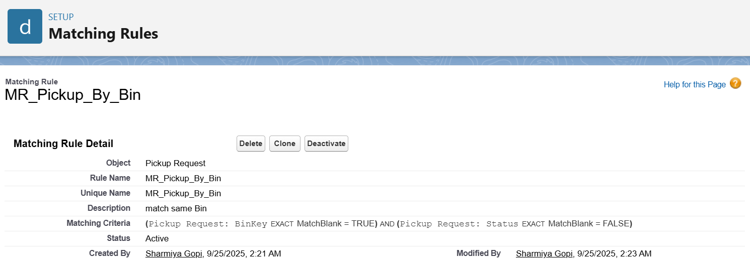

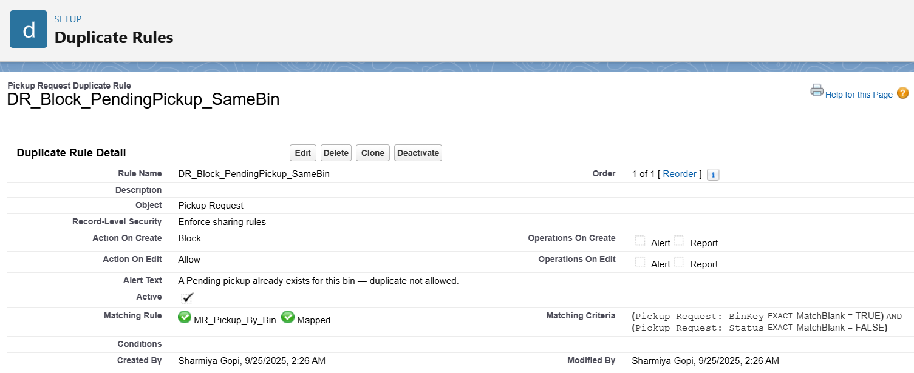

**➣Data Export & Backup**

**•** Weekly scheduled export to backup critical Waste & Recycling data.

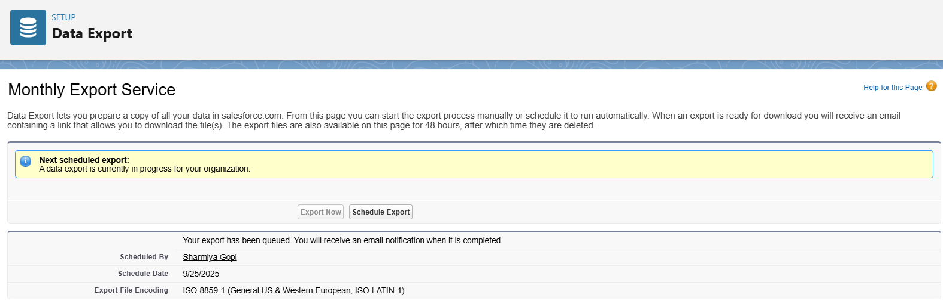

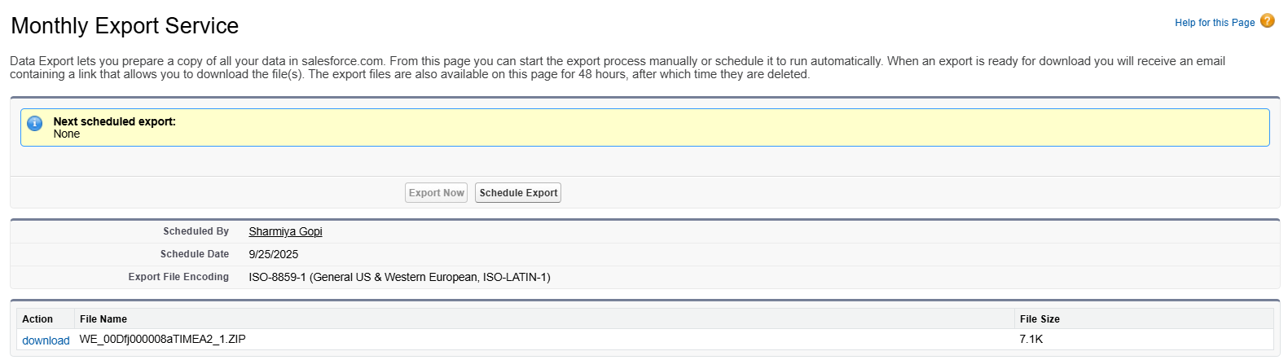

**➣Change Sets**

**•** Used to move configuration (objects, fields, flows, Apex) from Sandbox → Developer Org.

**•** Recommended for structured deployments.

**➣VS Code & SFDX**

**•** Used for developing and deploying LWCs + Apex classes.

**•** Example: LWC BinMap deployed via VS Code SFDX.